For Further Consideration of Chapter 1
Preface
“But are there any reliable eyewitness statements in existence to corroborate in the first place? This became the most important question I had to answer in my personal investigation of Christianity. Were the Gospel narratives eyewitness accounts or were they only moralistic mythologies? Were the Gospels reliable or were they filled with untrustworthy, supernatural absurdities?” (Page 21)
What do you think the Gospel accounts are?
“‘Christianity is a statement which, if false, is of no importance, and, if true, is of infinite importance. The one thing it cannot be is moderately important.’ Christianity, if it is true, is worthy of our investigation” (Page 21)
What are your thoughts on this statement?
What is the “infinite importance?”
Chapter 1
“All of us hold presuppositions impacting the way we see the world around us… you simply cannot enter an investigation with a philosophy that dictates the outcome” (Page 27)
How did you answer “What do you think the Gospel accounts are” from the preface? Why?
What doubts do you have about the Bible’s credibility, if any? Where do they come from?
Many times, people make claims such as “the Bible has been translated so many times that it has lost its original meaning.” Where does this information come from? It comes from a presupposed thought, because that statement is not factually true. People make many assumptions about the Bible, yet we often don’t do research to know if it’s accurate.
What do you think about Carl Sagan’s quote on page 28?
What is “philosophical naturalism” (Pages 27-29)? Why is it important to be open to supernatural forces when reading the Bible?
Are you open to the thought of there being a God?
“When I was an atheist, I did the very same thing. I stood in front of the evidence for God, interested in answering the question ‘Does God exist?’ But I began the investigation as a naturalist with the presupposition that nothing exists beyond natural laws, forces, and material objects. I was asking the question ‘Does a supernatural being exist?’ after first excluding the possibility of anything supernatural. Like Alan, I came to a particular conclusion because I started with it as my premise. This is the truest definition of bias, isn’t it? Starting off with your mind already made up” (Page 30)
Do you relate to where the author was? If so, explain. If not, how would you explain your reasoning for beliefs compared to the author?
“The question is not whether we have ideas, opinions, or pre-existing points of view; the question is whether we will allow these perspectives to prevent us from examining the evidence objectively” (Page 30).
Do you have any biases that lead you to not believing, whether if it's an event that happened in your past or even knowing that pursuing God requires sacrifice?
What a beginning!!

For Further Consideration of Chapter 2
When are times in your life where you don’t have proof of the answer but you have to pick the most reasonable answer?
This can be a past event or conclusions that you must come to daily.
How do you determine what is reasonable enough for you to believe?
What do you think happened to Jesus’s body and why do you believe that?
Did Jesus Christ die and resurrect from the dead?
Wallace explains abductive reasoning as “inferring to the most reasonable explanation” (Page 35). Can you place your faith in a “reasonable explanation?”
Wallace talks about distinguishing between “reasonable” and “possible” at the bottom of page 36. How do you determine what to believe if “all things are possible?”
What determines something as “reasonable enough” for you to believe it?
“What happened to Jesus of Nazareth? How can we explain His empty tomb? Did His disciples steal His body? Was He only injured on the cross and later recovered? Did He truly die and resurrect from the dead” (Page 42)?
What do you think happened to Jesus?
Do you think that Jesus died (Pages 45-46)?
Do you think that Jesus’s disciples lied about His resurrection (Pages 46-47)?
Do you think that Jesus’s followers “hallucinated” Jesus’s resurrection (Pages 47-49)?
Do you think that an imposter fooled Jesus’s followers (Pages 49-50)?
Do you think that Jesus’s followers all had visions based on the influence of one person’s vision (Pages 50-52)?
Do you think that the observation of Jesus's followers was distorted over time
(Pages 52-53)?
Wallace gives one problem with the thought that Jesus’s followers were accurately reporting the resurrection of Jesus: it requires supernatural power.
Does Jesus resurrecting from the dead provide a solution to each of the problems?
Wallace earlier said that investigators must be open to all possibilities. If you are open to the possibility of the supernatural existing, what is the most likely explanation for the evidence of Jesus’s resurrection?
What do you think about the two possibilities on page 54?
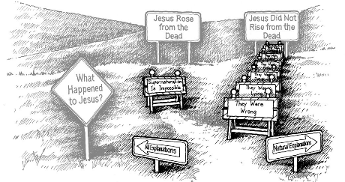
Wallace says that he used to think of faith as the opposite of reason and that atheists were the open-minded freethinkers while the Christians blindly followed teaching of leadership (Page 55).
What are your thoughts on this?
Do you come from a similar background?
Explain.

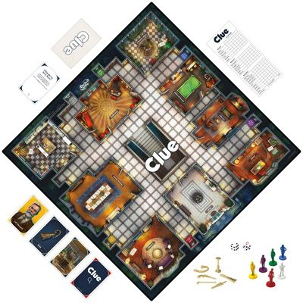
For Further Consideration of Chapters 3 and 4
Chapter 3: How would you explain the circumstantial evidence for
God? Do you find this evidence convincing? Why or why not?
What do you find most convincing?
In one of the reviews I read and linked to in our group, the writer
concludes his reading of this chapter with the comment:
“Prior to reading this book, I was unaware of the
comparative equality of direct and indirect evidence.
This section easily cleared up my misconception that
circumstantial evidence was somehow inferior to direct evidence. I will be a better apologist for it.”
How has it affected you?

Chapter 4: What are some reasons why we believe the Gospel writers were eyewitnesses? Based on what you read, explain the differences between seeing the Bible as inerrant and seeing the Bible as reliable.
There are “four critical areas of concern” regarding eyewitnesses:
Were they even there?
Have they been honest and accurate?
Can they be verified?
Do they have an ulterior motive?
“If the Gospel writers are found reliable, meeting the four criteria, we can accept their statements as the foundation for future decisions we make about the truth of Jesus's life and God's existence” (Page 86).
If the Gospel accounts are historically accurate, what does this mean about Jesus?
What does this mean about mankind?
What does this mean for you?
How do the Gospels meet Wallace’s criteria for normal witnesses, on page 87?
Why do you think Wallace is more concerned with the reliability than with the inerrancy and infallibility of the Bible (Page 88)?
What’s a big event in your life that you remember in great detail?
If you were to write about it 20 years after it happened, how accurate do you think you would be?
Why do you think the eyewitnesses of the Gospels felt that they had something of great importance to offer the world?
As always, thank you for being a part of this study with us. What an adventure!!
For Further Consideration of Chapters 5 and 6
Chapter 5: I wanted to highlight two things about this chapter:
Forensic Statement Analysis: “The careful study and analysis of the words (both written and spoken) provided by a suspect, witness, or victim. The purpose of forensic statement analysis is to determine truthfulness or deception on the part of the person making the statement.”
Once that ‘purpose is determined, it becomes our purpose to share it! I shared it with our AC guy, today, telling him about our demonstration of chapter 6.
Another thing that stood out about chapter 5 was this little observation Jason alluded to Sunday morning at church about pages 98 and 99:
“I had been interviewing and studying suspect and eyewitness statements for many years before I opened my first Bible. I approached the Gospels like I would any other forensic statement. Every little idiosyncrasy stood out for me. Every word was important. The small details interested me and forced me to dig deeper. As an example, the fact John never mentioned the proper name of Jesus’s mother (Mary) was curious to me. In his gospel, John repeatedly referred to Mary as “Jesus’s mother” or “the mother of Jesus” but never referred to her by name (as did the other gospel writers). Why would this be the case?
The answer might be found in the nineteenth chapter of John’s gospel when Jesus entrusted Mary to John at the crucifixion. Jesus told John that Mary was now his mother, and He told Mary that John was now her son. John took Mary and cared for her (as he would his own mother) from this point on. Writing the gospel of John many years later, John may have been uncomfortable calling his own mother by her formal name. I’m sure by this time in his life, John was referring to Mary as “my mother.” It doesn’t surprise me John would hesitate to call his adopted mother by her proper name in the gospel. The more I read the Gospels, the more interested I was in taking a forensic approach to read between the lines of the gospel writers. My interest reached its peak in the gospel of Mark.” It made me want to read each of them, starting with Mark, all over again from this ‘forensic’ perspective.
Chapter 6:
Separate Artifacts from Evidence
Why can we trust the biblical evidence pertaining to Jesus? Have there ever been scribal alterations to the biblical text that invalidate the evidence for Jesus?
In the Lego demonstration, did any of the other pieces change the appearance or the specifications of my original Lego?
When separated out, was it easier to determine the pieces that lined up with my original than it was when they were in the little bags?
Did a Google search for “Artifacts and Evidence” to SEE a practical application of them. You can really see the significance of both here, in this article!

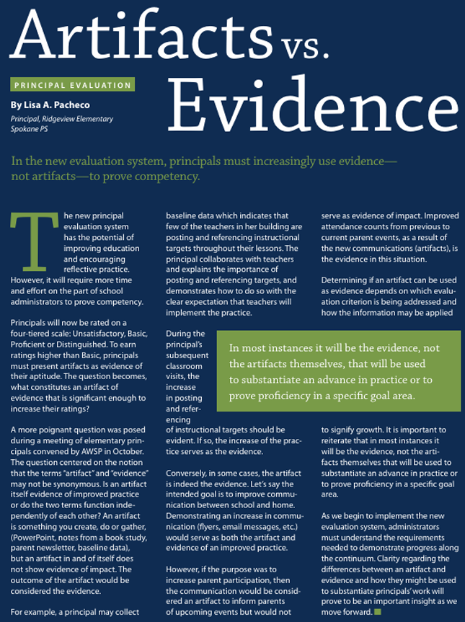
For Further Consideration of Chapters 7 through 10
I don’t know about you, but why would they scrunch together such meaty chapters into a four-part single night?! This is great material!! May the Holy Spirit bring it to our remembrance in our future endeavors to share Jesus with others. So good!!
Chapter 7: Resist Conspiracy Theories
If you could make any conspiracy theory, what would it be? What would you have to do to make generations after you continue to believe it?
How easy would it be for 120 witnesses to create a conspiracy theory while not being together? What challenges would arise (Page 126)?
“Successful conspiracies are unpressured conspiracies” (Page 128). How were the apostles pressured? Look at the way that all the Apostles died on page 129. Yikes! No, uh, pressure!
How do the Apostles’ eyewitness-martyrdom differ from those who are also martyrs for their own religious beliefs (Pages 129-130)?
Do you think that Jesus’s eyewitness followers created a conspiracy theory? Why or why not?
Chapter 8: Respect the “Chain of Custody”
What is the “chain of custody?”
Why is it important to document the chain of custody (Page 136)?
What was the purpose of the Council of Laodicea in AD 363? Not to hash out but to confirm!!
What is the purpose of establishing the “chain of custody” for the New Testament Gospels?
Do you hold the historicity of the Bible to the same standard as you hold other historical texts?
Chapter 9: “Know when “Enough is Enough”
Look at the table “The Escalating Standard of Proof” on page 145. At what point of evidence do you usually feel comfortable accepting something to be true?
How would you define what “beyond a reasonable doubt” means?
If you have any doubts regarding the Bible, would you place them in the rational, emotional, or volitional category (Page 146)?
“It’s important to remember that truth can be known even when some of the facts are missing. None of us has ever made a decision with complete knowledge of all the facts” (Page 147).
What are your thoughts on this quote?
“In courtrooms across America, jurors are asked to act (in the present) on the evidence available (from the past) to decide what ought to happen (in the future)” (Page 148).
What is at stake in the jurors' decisions? What is at stake for all people’s decisions?
Have you ever questioned “How can a good God exist with all of this suffering in the world?” How does Wallace explain this? (Starting at page 148)
“Are we rejecting the existence of God because there is no rational explanation for the existence of evil, or are we resisting volitionally because we stubbornly refuse to accept any explanation one might offer” (Pages 150-151)? What are your thoughts on this quote?
Why is the problem of evil not a problem with reasonable doubt (Page 152)?
Chapter 10: Prepare for an Attack
What is tolerance and how has it changed over time (Page 158)?
Do you believe in an objective truth? Why or why not?
What do you think of the quote “The claim ‘objective truth does not exist’ is self-refuting because it is, in fact, an objective claim about truth” (Page 159).
How do you know if someone is attacking the “micro” instead of the “macro” (Pages 162-163)?
What is Wallace’s response to people who deny the claims of Christianity because of Christians who were guilty of misbehavior (Pages 164-165)?
What would it look like to treat Christianity as a “perfect case” (Pages 165-166)? How do you think we should respond to people who demand a “perfect case?”
Have you heard any “alternative explanations” for Christianity? What are they? How did you hear about them? Were they reasonable?
Hey! If anyone feels like we could spend another week on this set of chapters because it contained more than just a week’s worth of going over, let me know.
Also, in the Participant Guide, is this question:
“Have you ever thought about how a jury is required to come to a decision, even without being able to obtain an answer to every question they had during the trial? How have you handled your own questions related to God, the Bible, or Christianity?”
May we, prayerfully, “handle” any questions you may personally have regarding God, the Bible, and Christianity?”
Jaclyn and I value each of you coming to our home for small group. We are grateful for your own unique perspective of our walks with God.
“If you catch a fish, prepare it, and give it to someone, they eat for a day. If you show someone how to fish and prepare it, they eat for a lifetime, though they may become a bit fishy.” ;) (See 2 Timothy 2:2)
Acts 5:34-39 gives us “Gamaliel’s Gambit”. 2000 years later they are still fighting against “God Himself.”
For Further Consideration of Chapter 11
Why is it important for someone to testify about an event sooner rather than later after the event occurred?
What is your idea on when the Gospels were written?
Why is this important to establishing the Bible as credible?
Were the Gospels written immediately after Jesus died?
Were they written 100 years after Jesus died?
How would that affect your trust in them?
What is the historical evidence to determine when the Gospels were written?
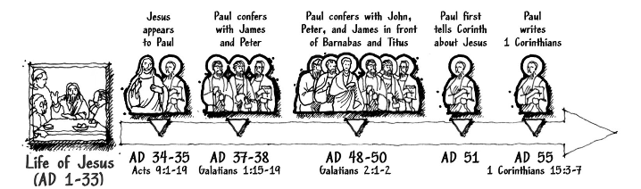
Wallace gives many pieces of evidence to show that the Gospels were written shortly after Jesus’s death (Points 1-11). Which reason stood out to you the most?
Out of the pieces of evidence that show the Gospels were written soon after Jesus’s death (Points 1-11), what is something that you learned that you didn’t know about before?
Wallace goes through many counter points that say that the Gospels were written later than Christianity claims (Points 12-16). Which argument stood out to you the most?
Out of the counter points that Wallace gave (Points 12-16), what is something that you learned that you didn’t know before?”

So look forward to seeing you at group, tonight! I hope you are enjoying the book and the ‘reasonable evidence’ for your faith in God!
Such a great book!!

For Further Consideration of Chapter 13: “Were They Accurate Over Time?”
How do you think stories are accurately preserved over time?
How would you know if a story wasn’t accurately preserved over time?
What do you know about the production of the New Testament?
Many people say that the Bible has been changed over time. Did you know that we can trace the truth of the Bible from the time of Jesus’s death to the time that the New Testament was produced 300 years later?
We will be looking into the ancient writings of the disciples’ disciples, and their disciples… and THEIR disciples… to see if the truth of the Bible has remained the same!
---
What is the importance of knowing that early writings, such as Ignatius and Polycarp, validate and reference the Gospels?
What is the importance of knowing that early writings validate and reference New Testament letters and refer to them as Scripture?
What was the importance of Wallace tracing the validation of New Testament Scripture from Jesus to the Council of Laodicea?
It was the Council of Laodicea that determined what writings would be officially categorized as divine Scripture and gave us what we know as the New Testament. Although the Council of Laodicea was around 350 AD (over 300 years after Jesus died), that doesn’t mean that writings were randomly added during those 300 years. We can trace back and confirm that the writings and the main concepts of the Gospel were not lost during those 300 years!
Look at the paragraph on the bottom of page 254 and the top of 255. What is the importance of recognizing what the earliest non-biblical, Christian documents say about Jesus?
What were the Dead Sea Scrolls and what did they prove about the accuracy of the scribes?
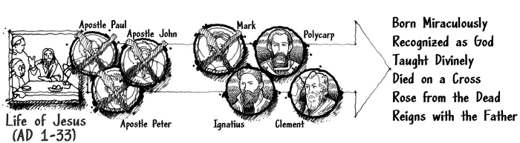
Wow!!

For Further Consideration of Chapter 14: “Are They Biased?”
Why is it important to understand people’s motives behind their actions?
How can you be sure of someone’s motives?
What do you believe were the motives of the Apostles for their ministries?
What if the Gospel writers lied?
Did Jesus Christ speak truth, die, and was He resurrected?
Is the Bible reliable?
Where do we go from here?
Postscript
Wallace stated that he could never take a blind leap of faith because he needed to make a reasonable decision based on evidence (Page 284). Do you relate to him?
Wallace also stated that his refusal to accept the supernatural prevented him from seeking God (Page 284). Do you relate to him?
Who is someone that you know that greatly demonstrates having faith in Jesus? What is different about their lives from many others’?
Afterword
What does the afterword imply about if you have questions regarding the reliability of the Bible?
- Research is needed! If you have a question, research to find the answer before choosing just to doubt.
Did the afterword answer any final questions that you still had?
Final Questions
Do you believe that Jesus lived?
Do you believe that Jesus died?
Do you believe that Jesus resurrected?
Do you believe that the Bible is truth?
What other questions do you have about Jesus and the Bible?
What are you going to do to find those answers?

